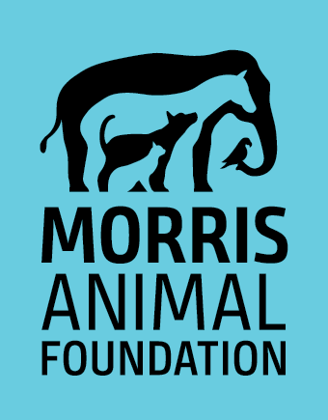
YEAR-END PROGRESS REPORT

Note: Approval of next year’s funding is conditioned on the conduct of the study so as to achieve the greatest possible progress consistent with the nature of the work. Any portion of the report may be shared with donors unless confidentiality is specifically requested by the PI. Please be aware that study reviewers may or may not have been reviewing ongoing study reports. The year-end report must comprehensively update the entire project including any changes and justifications.

- Grant ID and Title of Project:
- Principal Investigator (or Fellow and Mentor), Suffix(es) and Organization

- Date of report:
- Briefly describe the progress made toward the study’s goals and objectives (2-3 sentences). If no progress has been made, please explain.

- Is there anything the Foundation needs to be notified of at this time relevant to the study’s progress?
Note: any change in the study’s objectives, budget, personnel or timeline requires advance approval by Morris Animal Foundation. To request a study change or extension, please complete a Request for Study Change form (Click Here) and include it with your report.

- Scientific update - Re-state the study’s objectives and summarize the progress made for each – this portion of the report will be evaluated by the scientific advisory board.

- Lay language update - This portion of the report may be shared with Foundation stakeholders (e.g., donors, veterinarians) (2-3 sentences each).
- Summarize the hypothesis and objectives of your project. Which objectives have you completed to date?

- What work is planned during the next 6-12 months?

- Note the species/breed that is being studied and discuss other species/breeds that this work will benefit, if applicable.

- How will your project help animals in the short-term and/or long-term?

- How might veterinary professionals use information gained from this study to improve patient care? Will it change current methods for either the diagnosis or treatment of disease? If so, how?

- Note any problems you’ve encountered and solutions to those problems.

- For Fellowship Training awards, please provide a brief update on the training received through this project as well as any additional training opportunities you have had.

- If this was not a Fellowship Training grant please describe any training component(s) of your project including any involvement of graduate students, veterinary students, post-docs, etc.

- Describe any “successes” the study has experienced during this period. If you have preliminary results to report that directly benefit a specific patient or population, please do so here. The Foundation also appreciates stories of how studies contribute to a researcher’s professional growth.

- If live animals are involved in this study, including client owned animals, please comment briefly on the animal care protocols being used (housing, pain management, enrichment, etc.) and include the expiration date of the IACUC protocol (MAF reserves the right to request a copy of current IACUC protocol).

- List all past and currently accepted publications. Include the name(s) and date of the journal(s) and all authors. Please include (pdf) a copy/reprint of each article.
Note: Acknowledgement of Morris Animal Foundation funding is required in all publications (please include the study’s Grant ID # in the acknowledgement).

- List all past and currently accepted presentations. Please attach copies of all presentation abstract(s) (include the conference name, date of presentation and location).
Note: Acknowledgement of Morris Animal Foundation funding is required in all presentations

- Please forward digital photographs of yourself, colleagues, mentors, and animals involved in your study. Action photos in the laboratory or field, photos of humans and animals together, and high quality microscope images are particularly appreciated. Ideally, photos should be at least 300 dpi, 4 x 6 in. Please provide photo credit if applicable.
Note: All materials provided shall be deemed to be accompanied by permission to use such materials and the names and likenesses of individuals in the Foundation’s publications, presentations, and online for awareness and fundraising purposes.

