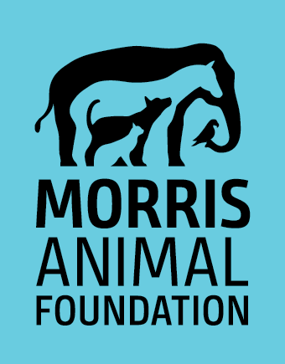
MID-YEAR PROGRESS REPORT

Note: Any portion of the report may be shared with donors unless confidentiality is specifically requested by the PI.
- Grant ID and Title of Project:
- Principal Investigator (or Fellow and Mentor), Suffix(es) and Organization

- Date of report:
- Briefly describe the progress made toward the study’s goals and objectives (2-3 sentences). If no progress has been made, please explain.

- Lay language update - This portion of the report may be shared with Foundation stakeholders (e.g., donors, veterinarians) (2-3 sentences each).
- Summarize the hypothesis and objectives of your project. Which objectives have you completed to date?

- What work is planned during the next 6-12 months?

- Note any problems you’ve encountered and solutions to those problems.

- For Fellowship Training awards, please provide a brief update on the training received through this project (during this period) as well as any additional training opportunities you have had.

- Is there anything the Foundation needs to be notified of at this time relevant to the study’s progress?
Note: any change in the study’s objectives, budget, personnel or timeline requires advance approval by Morris Animal Foundation. To request a study change or extension, please complete a Request for Study Change form (Click Here) and include it with your report.

- Describe any “successes” the study has experienced during this period. If you have preliminary results to report that directly benefit a specific patient or population, please do so here. The Foundation also appreciates stories of how studies contribute to a researcher’s professional growth.

